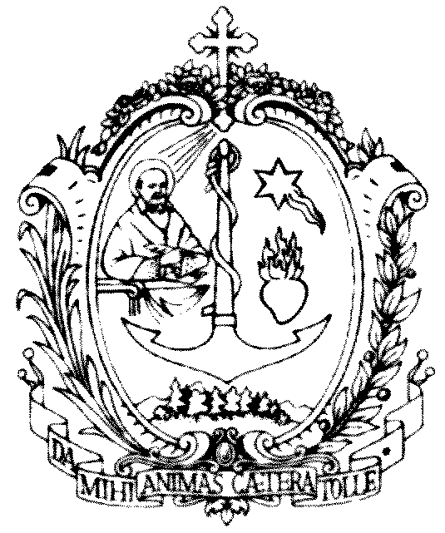SOCIETA’ DI SAN FRANCESCO DI SALES

sede centrale salesiana

Via Marsala 42 - 00185 Roma

*Il Postulatore Generale*

*per le Cause dei Santi*

Rome, 31 December 2024

**Dossier General Postulation Salesians of Don Bosco - 2024**

*"Let us not forget that it is precisely the saints who drive the Church forward and make it grow"*

*(Pope Francis).*

*"From now on, let it be our motto: let the holiness of children be proof of the holiness of the father."*

*(Don Rua)*

It is necessary to express deep gratitude and praise to God for the holiness already recognized in the Salesian Family of Don Bosco and for the one in the process of recognition. The outcome of a Cause of Beatification and Canonization is an event of extraordinary importance and ecclesial value. In fact, it is a matter of discerning the reputation of holiness of a baptized person, who lived the Gospel beatitudes to a heroic degree or who gave his life for Christ.

From Don Bosco to our own day there is attested a tradition of holiness to which attention deserves attention, because it is the incarnation of the charism that originated from him and that was expressed in a plurality of states of life and forms. These are men and women, young people and adults, consecrated and lay people, bishops and missionaries who in historical, cultural and social contexts different in time and space have made the Salesian charism shine with a singular light, representing a heritage that plays an effective role in the life and community of believers and for people of good will.



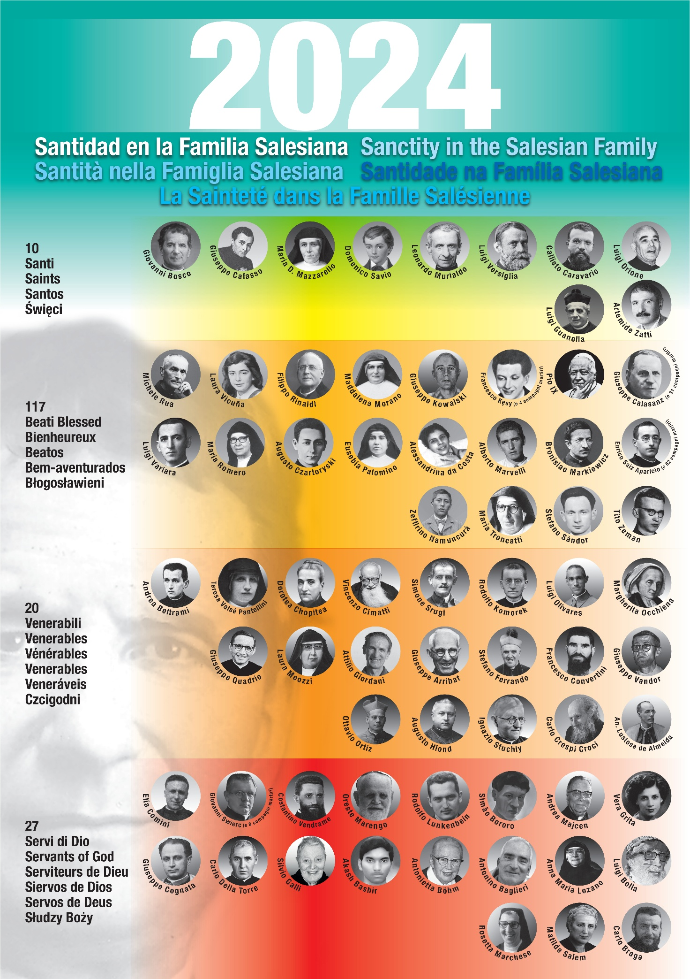

**1. List as at 31 December 2024**

Our Postulation involves 179 Saints, Blesseds, Venerables, Servants of God.

The Causes followed directly by the Postulation are 61 (+ 5 extra).

**SAINTS (10)**

**Saint John Bosco**, priest (date of Canonization: April 1, 1934) – (Italy)

**Saint Joseph Cafasso**, priest (22 June 1947) – (Italy)

**Saint Maria D. Mazzarello**, virgin (24 June 1951) – (Italy)

**Saint Dominic Savio**, adolescent (12 June 1954) – (Italy)

**Saint Leonard Murialdo**, priest (3 May 1970) – (Italy)

**Saint Luigi Versiglia**, bishop, **martyr** (October 1, 2000) – (Italy - China)

**Saint Callistus Caravario**, priest, **martyr** (October 1, 2000) – (Italy - China)

**Saint Luigi Orione**, priest (May 16, 2004) – (Italy)

**Saint Luigi Guanella**, priest (23 October 2011) – (Italy)

**Saint Artemide Zatti**, religious (9 October 2022) – (Italy – Argentina)

**BLESSED (117)**

**Blessed Michael Rua**, priest (date of beatification: October 29, 1972) – (Italy)

**Blessed Laura Vicuña**, adolescent (September 3, 1988) – (Chile – Argentina)

**Blessed Filippo Rinaldi**, priest (April 29, 1990) – (Italy)

**Blessed Magdalene Morano**, virgin (5 November 1994) – (Italy)

**Blessed Joseph Kowalski**, priest, **martyr** (June 13, 1999) – (Poland)

**Blessed Francis Kęsy**, layman, and **4 companion martyrs** (June 13, 1999) – (Poland)

**Czesław Jóźwiak**, layman

**Edward Kaz ́mierski**, layman

**Edward Clinic**, Laico

**Jarogniew Wojciechowski**, layman

**Blessed Pius IX**, Pope (September 3, 2000) – (Italy)

**Blessed Joseph Calasanz**, priest, and **31 companion martyrs** (March 11, 2001) – (Spain)

**Antonio Maria Martin Hernandez**, priest

**Recaredo de los Ríos Fabregat**, priest

**Giuliano Rodríguez Sánchez**, priest

**Giuseppe Giménez López**, priest

**Augustine García Calvo**, layman

**Giovanni Martorell Soria**, priest

**Giacomo Buch Canal**, layman

**Pietro Mesonero Rodríguez**, chierico

**Giuseppe Otín Aquilué**, priest

**Alvaro Sanjuán Canet**, priest

**Francesco Bandrés Sánchez**, priest

**Sergio Cid Pazo**, priest

**Giuseppe Batalla Parramó**, priest

**Giuseppe Rabasa Bentanachs**, layman

**Gil Rodicio Rodicio**, layman

**Angelo Ramos Velázquez**, layman

**Filippo Hernández Martínez**, cleric

**Zaccaria Abadía Buesa**, cleric

**Giacomo Ortiz Alzueta**, layman

**Saverio Bordas Piferrer**, cleric

**Felice Vivet Trabal**, cleric

**Michael Domingo Cendra**, cleric

**Giuseppe Caselles Moncho**, priest

**Joseph Castell Camps**, priest

**Giuseppe Bonet Nadal**, priest

**Giacomo Bonet Nadal**, priest

**Alessandro Planas Saurí**, lay collaborator

**Eliseo García García**, layman

**Giulio Junyer Padern**, priest

**María Carmen Moreno Benítez**, vergin

**María Amparo Carbonell Muñoz**, vergin

**Blessed Luigi Variara**, priest (April 14, 2002) – (Italy – Colombia)

**Blessed Maria Romero Meneses**, virgin (April 14, 2002) – (Nicaragua – Costa Rica)

**Blessed Augustus Czartoryski**, priest (April 25, 2004) – (France – Poland)

**Blessed Eusebia Palomino**, virgin (April 25, 2004) – (Spain)

**Blessed Alexandrina M. Da Costa**, laywoman (April 25, 2004) – (Portugal)

**Blessed Alberto Marvelli**, layman (5 September 2004) – (Italy)

**Blessed Bronislaus Markiewicz**, priest (June 19, 2005) – (Poland)

**Blessed Henry Saiz Aparicio**, priest, and **62 companion martyrs** (October 28, 2007) – (Spain)

**Felice González Tejedor**, priest

**Giovanni Codera Marqués**, coadjutor

**Virgilio Edreira Mosquera**, cleric

**Paolo Gracia Sánchez,** layman

**Carmelo Giovanni Pérez Rodríguez**, subdeacon

**Teodulo González Fernández**, cleric

**Tommaso Gil de la Cal**, aspirant

**Federico Cobo Sanz**, aspirant

**Igino de Mata Díez**, aspirant

**Giusto Juanes Santos**, cleric

**Vittoriano Fernández Reinoso**, cleric

**Emilio Arce Díez**, layman

**Raimondo Eirín Mayo**, layman

**Matteo Garolera Masferrer**, layman

**Anastasio Garzón González**, layman

**Francesco Giuseppe Martín López de Arroyave**, layman

**Giovanni de Mata Díez**, lay collaborator

**Pio Conde Conde**, priest

**Sabino Hernández Laso**, priest

**Salvatore Fernández Pérez**, priest

**Nicola de la Torre Merino**, layman

**Germano Martín Martín**, priest

**Giuseppe Villanova Tormo**, priest

**Stefano Cobo Sanz**, cleric

**Francesco Edreira Mosquera**, cleric

**Emanuele Martín Pérez**, cleric

**Valentino Gil Arribas**, layman

**Pietro Artolozaga Mellique**, cleric

**Emanuele Borrajo Míguez**, cleric

**Dionisio Ullívarri Barajuán**, layman

**Michele Lasaga Carazo**, priest

**Luigi Martínez Alvarellos**, cleric

**John Larragueta Garay**, cleric

**Fiorenzo Rodríguez Güemes**, cleric

**Pasquale de Castro Herrera**, cleric

**Stefano Vázquez Alonso**, layman

**Eliodoro Ramos García**, layman

**Giuseppe Maria Celaya Badiola**, layman

**Andrea Jiménez Galera**, priest

**Andrea Gómez Sáez**, priest

**Antonio Cid Rodríguez**, layman

**Antonio Torrero Luque**, priest

**Antonio Enrico Canut Isús**, priest

**Michele Molina de la Torre**, priest

**Paolo Caballero López**, priest

**Onorio Hernández Martín**, cleric

**John Louis Hernández Medina**, cleric

**Antonio Mohedano Larriva**, priest

**Antonio Fernández Camacho**, priest

**Giuseppe Limón Limón**, priest

**Giuseppe Blanco Salgado**, layman

**Francesco Míguez Fernández**, priest

**Emanuele Fernández Ferro**, priest

**Felice Paco Escartín**, priest

**Tommaso Alonso Sanjuán**, layman

**Emanuele Gómez Contioso**, priest

**Antonio Pancorbo López**, priest

**Stefano García García**, layman

**Raffaele Rodríguez Mesa**, layman

**Antonio Rodríguez Blanco**, diocesan priest

**Bartolomeo Blanco Márquez**, layman

**Teresa Cejudo Redondo**, lay

**Blessed Zeffirino Namuncurá**, layman (11 novembre 2007) – (Argentina – Italia)

**Blessed Maria Troncatti**, virgin (November 24, 2012) – (Italy – Ecuador)

Decree on the miracle: November 25, 2024

Canonization September 7, 2025?

**Blessed Stephen Sándor**, religious, **martyr** (19 October 2013) – (Hungary)

**Blessed Titus Zeman**, priest, **martyr** (30 September 2017) – (Slovakia).

**VENERABLE (20)**

**Ven. Andrea Beltrami**, priest, (date of the Decree *super virtutibus:* December 15, 1966) – (Italy)

**Ven. Teresa Valsè Pantellini**, virgin (July 12, 1982) – (Italy)

**Ven. Dorotea Chopitea**, laywoman (June 9, 1983) – (Spain)

**Ven. Vincenzo Cimatti**, priest (December 21, 1991) – (Italy – Japan)

**Ven. Simone Srugi**, religious (April 2, 1993) – (Palestine)

**Ven. Rodolfo Komorek**, priest (6 aprile 1995) – (Polonia – Brasile)

**Ven. Luigi Olivares**, bishop (December 20, 2004) – (Italy)

**Ven. Margherita Occhiena**, laywoman (23 October 2006) – (Italy)

**Ven. Giuseppe Quadrio**, priest (December 19, 2009) – (Italy)

**Ven. Laura Meozzi**, virgin (June 27, 2011) – (Italy – Poland)

**Ven. Attilio Giordani**, layman (9 October 2013) – (Italy – Brazil)

**Ven. Joseph Augustus Arribat**, priest (8 July 2014) – (France)

**Ven. Stefano Ferrando**, bishop (3 March 2016) – (Italy – India)

**Ven.** **Francesco Convertini**, priest (20 January 2017) – (Italy – India)

**Ven. Joseph Vandor**, priest (20 January – 2017) – (Hungary – Cuba)

**Ven. Octavius Ortiz Arrieta Coya**, bishop (27 February 2017) – (Peru)

**Ven. Augusto Hlond**, cardinal (19 May 2018) – (Poland)

**Ven. Ignazio Stuchly**, priest (21 December 2020) – (Czech Republic)

**Ven. Carlo Crespi Croci**, priest (23 March 2023) – (Italy – Ecuador)

**Ven. Antonio De Almeida Lustosa**, bishop (22 June 2023) – (Brazil)

**SERVANTS OF GOD (27)**

**The Causes are listed according to the progress**

***Positio examined by cardinals and bishops***

**Elia Comini**, priest (Italy) **martyr**

Peculiar Congress of Theologians: May 5, 2022

Peculiar Congress of Theologians: April 11, 2024

Ordinary session of Cardinals and Bishops: 10 December 2024

Decree on martyrdom: 18 December 2024

***Positio examined by theologians***

**John Świerc**, priest and **8 companion martyrs** (Poland)

**Ignacio Dobiasz**, priest

**Francis Harazim**, priest

**Casimiro Wojciechowski**, priest

**Ignazio Antonowicz**, priest

**Lodovico Mroczek**, priest

**Carlo Golda**, priest

**Vladimiro Eyes**, priest

**Francesco Miśka**, priest

Positio delivered: 21 July 2022

Peculiar historical congress. March 28, 2023

Ordinary session of the Cardinal and Bishops: June 2025

***Positio delivered***

**Costantino Vendrame**, priest (Italy – India)

Decree of validity of the Diocesan Inquiry: 1 February 2013

Positio delivered: 19 September 2023

Peculiar Congress of Theologians: January 23, 2025

**Oreste Marengo**, bishop (Italy – India)

Decree of validity of the Diocesan Inquiry: 6 December 2013

Position delivered:28 May 2024

Peculiar Theologians Congress: September-October 2025

**Rodolfo Lunkenbein**, priest (Germany – Brazil) and **Simão Bororo**, layman (Brazil), **martyrs**

Decree of validity of the Diocesan Inquiry: 16 December 2020

Positio delivered: 28 November 2024

Peculiar Theologians Congress: September-October 2025

***The drafting of the Positio is underway***

**Andrea Majcen**, priest (Slovenia – Cina – Vietnam)

Decree of validity of the Diocesan Inquiry: 23 October 2020

**Vera Grita**, laywoman (Italy)

Decree of validity of the Diocesan Inquiry: 14 December 2022

**Cognata Giuseppe**, bishop (Italy)

Decree of validity of the Diocesan Inquiry: 11 January 2023

**Carlo Della Torre**, priest (Italy – Thailand)

Decree of validity of the Diocesan Inquiry: 1 April 2016

**Silvio Galli**, priest (Italy)

Decree of validity of the Diocesan Inquiry: 19 October 2022

**Akash Bashir**, layman, martyr (Pakistan)

Decree of validity of the Diocesan Inquiry: 24 October 2024

***Waiting for validity of the Diocesan Inquiry***

**Antonietta Böhm**, virgin (Germany – Mexico)

Opening of the Diocesan Inquiry: 7 May 2017

Diocesan Inquiry Closed: 28 April 2024

Validity of the Diocesan Inquiry

**Antonino Baglieri**, layman (Italy)

Opening of the Diocesan Inquiry: 2 March 2014

Closure of the diocesan inquiry. May 5, 2024

Validity of the Diocesan Inquiry

***Cause temporarily stopped***

**Anna Maria Lozano**, virgin (Colombia)

Closure of the Diocesan Inquiry: 19 June 2014

***The diocesan inquiry is underway***

**Luigi Bolla**, priest (Italy – Ecuador – Peru)

Opening of the Diocesan Inquiry: 27 September 2021

Closure of the Diocesan Inquiry

**Rosetta Marchese**, virgin (Italy)

Opening of the Diocesan Inquiry: 30 April 2021

Closure of the Diocesan Inquiry

**Matilda Salem**, laywoman (Syria)

Opening of the Diocesan Inquiry: 20 October 1995

**Carlo Braga,** priest (Italy – China – Philippines)

Opening of the Diocesan Inquiry: 30 January 2014

**EXTRA CAUSES FOLLOWED BY POSTULATION (5)**

**Venerabile COSTA DE BEAUREGARD CAMILLO,** PRIEST (France)

The Decree *super virtutibus:* January 22, 1991

Medical consultation *super miro*: March 30, 2023

Peculiar Congress of Theologians: October 19, 2023

Ordinary Session of Cardinals and Bishops: 20 February 2024

Beatification: 17 May 2025

**Venerable BARELLO MORELLO CASIMIRO,** Franciscan tertiary (Italy – Spain)

The Decree *super virtutibus:* 1 July 2000

**Venerable TYRANOWSKI GIOVANNI,** layman (Poland)

The Decree *super virtutibus*: 20 January 2017

**Venerable BERTAZZONI AUGUSTO,** bishop (Italy)

The Decree *super virtutibus:* October 2, 2019

**Venerable CANELLI FELICE,** priest (Italy)

The Decree *super virtutibus*: May 22, 2021

Also to be remembered are the Saints, Blesseds, Venerables and Servants of God who at different times and in different ways have met with the Salesian charism such as: the Blessed, Edvige Carboni, the Servant of God Cardinal Giuseppe Guarino, founder of the Apostles of the Holy Family, the Servant of God Salvo d'Acquisto, past pupil and numerous others.

**2. EVENTS OF 2024**

On Tuesday, January 16, 2024, the opening session for the **canonical recognition and conservation treatment of the mortal remains of the Venerable Camille Costa de Beauregard** (1841-1910), diocesan priest, took place at the chapel of the Bocage Foundation in Chambéry.

On February 27, 2024, in the **Ordinary Session of the Cardinals and Bishops** of the Dicastery for the Causes of Saints, a positive vote was given (7 out of 7) to the alleged miracle attributed to the intercession of **the Venerable Camille Costa de Beauregard**, diocesan priest (1841-1910), which occurred to the child René Jacquemond, for healing from "intense keratoconjunctivitis with grinding of the cornea, strong perikeratic injection, redness and injection of the conjunctiva, photophobia and tearing of the right eye due to violent trauma from the plant-burdock agent" (1910).

On 7 March 2024, the **Medical Advisory Board of the Dicastery for the Causes of Saints** gave a positive opinion, with all affirmative votes, to the **alleged miracle attributed to the intercession of Blessed Maria Troncatti**, Daughter of Mary Help of Christians (1883-1969), from "open brain trauma with comminuted fracture of the skull, exposure of brain tissue in the right fronto-parieto-temporal area and state of coma (G6)" (2015).

On 14 March 2024, the Supreme Pontiff authorized the same Dicastery to **promulgate the Decree concerning the miracle** attributed to the intercession of the **Venerable Servant of God Camillo Costa de Beauregard,** diocesan priest; born in Chambéry (France) on 17 February 1841 and died there on 25 March 1910. The miracle, which took place in 1910, concerns the child René Jacquemond, cured of "intense keratoconjunctivitis with grinding of the cornea, strong perikeratic injection, redness and injection of the conjunctiva, photophobia and tearing of the right eye due to violent trauma from the plant-burdock agent" (1910).

On 15 March 2024 in Lahore (Pakistan) **the Diocesan Inquiry into the** Cause of Beatification and Canonization of **Akash Bashir (1994-2015),** a layman, a former pupil of Don Bosco, killed in hatred of the faith, was closed. It is the first Cause of Beatification in Pakistan.

On 11 April 2024, during the **special Congress of Theological Consultors** at the Dicastery for the Causes of Saints, a positive opinion was expressed on the *Positio super martyrio* **of Servant of God Elia Comini,** Professed Priest of the Salesian Society of St. John Bosco (1910-1944), killed in hatred of the faith in the Nazi massacre of Monte Sole on 1 October 1944.

On April 28, 2024, in Cuautitlán (Mexico) **closing of the Diocesan Inquiry** of the Cause of the Servant of God **Antonieta Böhm** (1907-2008), Daughter of Mary Help of Christians.

On May 5, 2024, in Modica (Ragusa) **closing of the Diocesan Inquiry of the Servant of God Antonino Baglieri** (1951-2007), Layman, Volunteer with Don Bosco.

On May 28, 2024, the **peculiar Congress of Theologians of the Dicastery for the Causes of Saints** gave a positive vote to the **alleged miracle attributed to the intercession of Blessed Maria Troncatti**, Daughter of Mary Help of Christians (1883-1969), from "open brain trauma with comminuted fracture of the skull, exposure of brain tissue in the right fronto-parieto-temporal area and state of coma (G6)" (2015).

On May 31, 2024, the volume of the Positio super Vita, Virtutibus et Fama Sanctitatis **by the Servant of God Oreste Marengo (1906-1998), Salesian missionary bishop in Northeast India,** was delivered to the Dicastery for the Causes of Saints in the Vatican.

On Tuesday, June 4, 2024, at the "Zeffirino Namuncurà" community in Rome, **the new premises of the Salesian General Postulation were inaugurated and blessed by the Rector Major, Cardinal Ángel Fernández Artime.**

On 24 November 2024, the Dicastery for the Causes of Saints in the Ordinary Congress gave **legal validity to the Diocesan Inquiry for the Cause of Beatification and Canonization of the Servant of God Akash Bashir** (Risalpur 22 June 1994 - Lahore 15 March 2015) Layman, Past Pupil of Don Bosco.

On 19 November 2024, in the **Ordinary Session of the Cardinals and Bishops** of the Dicastery for the Causes of Saints, **a positive vote was given to the alleged miracle** attributed to the intercession of **Blessed Maria Troncatti**, Professed Religious of the Congregation of the Daughters of Mary Help of Christians (1883-1969), which occurred miraculously healed of a Lord from "Open cranio-encephalic trauma with comminuted fracture of the skull, loss of brain substance and exposure of brain tissue in the right front-parieto-temporal area, diffuse axonal damage (DAI), severe coma evolved in a type 2 vegetative state", which occurred in 2015 in Ecuador.

On 25 November 2024, the Holy Father authorized the same Dicastery to promulgate the Decree concerning

**- the miracle attributed to the intercession of Blessed Maria Troncatti**, a professed nun of the Congregation of the Daughters of Mary Help of Christians, born in Córteno Golgi, Italy, on 16 February 1883 and died in Sucúa, Ecuador, on 25 August 1969.

On November 28, 2024, the volume of the Positio super martyrio of the Servants of God Rodolfo Lunkenbein, **Professed Priest of the Society of St. Francis de Sales** and Simão Bororo**, Layman, killed in hatred of the faith on July 15, 1976,** was delivered to the Dicastery for the Causes of Saints in the Vatican.

On Tuesday, December 3, 2024, **the Theological Consultors** of the Dicastery for the Causes of Saints, during the Peculiar Congress, **responded affirmatively regarding the Positio super martyrio of the Servants of God John Świerc and VIII Companions**, Professed Priests of the Society of St. Francis de Sales, killed in odium fidei in the Nazi extermination camps in the years 1941-1942.

On Tuesday, December 10, 2024, during the **Ordinary Session of Cardinals and Bishops** at the Dicastery for the Causes of Saints, a positive opinion was expressed regarding the *Positio super martyrio* **of Servant Elia Comini,** Professed Priest of the Salesian Society of St. John Bosco (1910-1944), killed in hatred of the faith in the Nazi massacre of Monte Sole on October 1, 1944.

On Wednesday, December 18, 2024, **the Holy Father Francis authorized** the Dicastery for the Causes of Saints to promulgate **the Decree** concerning: **the martyrdom of the Servant of God Elia Comini,** professed priest of the Society of St. Francis de Sales; born on May 7, 1910 in Calvenzano di Vergato (Italy, Bologna) and killed, in hatred of the Faith, in Pioppe di Salvaro (Italy, Bologna) on 1 October 1944.

**3.** **In 2024 we recalled:**

**125**

15 December 1899 Eusebia Palomino Yenes was born in Cantalpino (Spain)

**75**

December 11, 1949, Don Rodolfo Komorek died in São José dos Campos. (Brazil)

**50**

14 August 1974 Msgr. Antonio de Almeida Lustosa died in Carpina (Brazil)

**25**

June 13, 1999, Beatification in Warsaw of Fr. Joseph Kowalsky and 5 young Oratorians.

30 settembre 1999 muore don Andrej Majcen and Ljubljana – Rakovnik (Slovenia)

**4. The commitment to spread the knowledge, imitation and intercession of the members of our Family who are candidates for holiness**

**Tips for promoting a Cause.**

* To encourage **prayer with the intercession** of the Blessed, Venerable Servant of God, through images (including relics ex-indumentis), brochures, books... to be spread in families, parishes, religious houses, spirituality centers, hospitals to ask for the grace of miracles and favors through the intercession of the Blessed, Venerable Servant of God.
* The dissemination of the **novena** Blessed, Venerable Servant of God, invoking his intercession in various cases of material and spiritual need, is particularly effective.

Two formative elements are emphasized: the value of insistent and trusting prayer and that of community prayer. Let us recall the biblical episode of Naam the Syrian (2 Kings 5:1-14), where we see several elements: the signaling of the man of God by a maiden, the injunction to bathe seven times in the Jordan, the indignant and resentful refusal, the wisdom and insistence of Naam's servants, the obedience of Naam, the obtaining not only of physical healing but of salvation. Let us also recall the description of the first community of Jerusalem, when it is stated: "All these persevered and prayed with one accord, together with some of the women and Mary the mother of Jesus, and his brethren" (Acts 1:14).

* It is advisable **to take care of a moment of prayer and commemoration every month on the day of the date of death of the** Blessed (Venerable) Servant of God.

- Publish a **Sheet** that informs about the progress of the Cause, particular anniversaries and events, testimonies, graces... to emphasize that the Cause is alive and accompanied.

* To curate a **commemorative day** once a year, highlighting particular aspects or anniversaries of the figure of the Blessed (Venerable) Servant of God, involving groups that are particularly "interested" in his or her witness (e.g. priests, religious, young people, families, doctors, missionaries...).
* To collect and document the **graces and favors** that are attributed to the Blessed, (Venerable) Servant of God. It is useful to have a notebook in which to write down and report the graces requested and those received, as a testimony to the reputation of both holiness and signs. In particular, if it is a question of healing and/or alleged miracle, it is important to urgently collect all the **medical documentation** that proves the case and the evidence attesting to the intercession.
* To set up a **Committee** that is committed to promoting this Cause also in view of Beatification and Canonization. Members of this Committee should be people who are particularly sensitive to the promotion of the Cause: representatives of the diocese and the parish of origin, leaders of groups and associations, doctors (for the study of alleged miracles), historians, theologians and experts in spirituality...
* To promote knowledge through the ***drafting of the biography****,* ***the critical edition of the writings* and other multimedia productions**.
* Periodically present the figure of the Blessed, (Venerable) Servant of God in the **Parish Bulletin and in the diocesan newspaper, in the Salesian Bulletin.**
* Have a **website or a link** dedicated to the Blessed, (Venerable) Servant of God with his/her life, data and news related to the Cause of Beatification and Canonization, request for prayers, reporting of graces...
* Review and reorder the **environments** where he/she has lived. Organize an **exhibition space.** To elaborate **a spiritual itinerary in his footsteps**, enhancing places (birthplace, church, living environments...) and signs.
* To organize an **archive** with all the cataloged and computerized documentation relating to the Blessed, (Venerable) Servant of God.
* To create an **economic fund** to support both the expenses of the Postulation of the Cause and the work of promotion and animation of the Cause itself.
* To promote **works of charity and education** in the name of the Blessed, (Venerable) Servant of God, through projects, twinning...

**5. Pay particular attention to alleged miracles!**

* To take care of our "theological" gaze to grasp the miracles that take place every day in our lives and around us.
* Pray and have others pray for the various cases that arise and ask that through the intercession of a Servant of God or Venerable or Blessed, the Lord intervene with his grace and work not only a miracle objectively concerning bodily health, but also a true and sincere conversion.
* To make people better understand what a "demonstrable" miracle is and what it is used for in a Cause of canonization, showing not only the scientific, medical but also the theological aspect.
* Appoint a person in charge to whom to communicate and report graces and alleged miracles. Following a Cause to certify a miracle is a very great commitment for a promoter who must demonstrate true love for the Servant of God.
* To raise awareness that we need to have more faith in the intercession of our saints.
* Communicate when we ask for a grace to unite us in prayer. Do not tire of praying.
* Follow better and personally the people to whom the material is given (novenas, holy cards, etc.) and also carefully choose the places where to do it.
* It is important to sensitize the faithful to continuous prayer sustained by great faith and always ready to accept God's will. We can learn by looking at the lives and sufferings our saints have experienced.
* In addition to prayers, it is important to be close to families who have great problems and give them some relics.
* In the event of a presumed miracle, it is necessary to proceed rigorously using a scientific methodology in collecting evidence, testimonies, medical opinions, etc., and possibly ordering all the information in chronological sequence.

A miracle is composed of two essential elements: the scientific and the theological. The second, however, presupposes the first.

You need to prepare

1. a brief and accurate report on the particular circumstances that characterized the case; this consists in a chronological case of all the elements of the prodigious fact, both those concerning the scientific and theological elements. The chronological case involves: generality of the healed; symptoms of the disease, chronology of medical-scientific events; indication of the decisive hours of recovery, clarification of the diagnosis and prognosis of the case, highlighting all the research performed. Outline the therapy followed, illustrate the healing modality, i.e. when the last observation before healing was performed, the completeness of the healing, presented in great detail and the permanence of the healing.

2. A list of texts that can contribute to the search for the truth of the case (healed, relatives, doctors, nurses, people who prayed...).

3. All documents relating to the case. Medical, clinical and instrumental documents (e.g., medical records, medical reports, laboratory tests and instrumental investigations) are required on the alleged miraculous healings.

**6. Initial Discernment Before Initiating a Cause**

First of all, it is necessary for the Provincial and his Council or the Superior or Head of a group to investigate and document with the utmost diligence the *candidate's fama sanctitatis et signorum* and the timeliness of the Cause, in order to verify the truth of the facts and the consequent formation of a justified moral certainty. Furthermore, it is essential that the Cause in question concerns a significant and significant portion of the people of God and is not the intention of only some group, if not of some person. All this involves a more motivated and documented initial discernment, to avoid wasting energy, strength, time and resources.

It is then essential to identify the right person (Vice Postulator) who takes the Cause to heart and has the time and the opportunity to follow it in all its stages.

It should also be remembered that initiating and continuing a Cause requires a considerable investment of resources in terms of people and economic contributions.

***Conclusion***

Holiness recognized, or in the process of being recognized, on the one hand is already the realization of evangelical radicalism and fidelity to Don Bosco's apostolic plan, to which we look as a spiritual and pastoral resource; on the other hand, it is a challenge to live one's vocation faithfully in order to be available to bear witness to love to the extreme. Our Saints, Blesseds, Venerables and Servants of God are the authentic incarnation of the Salesian charism and of the *Constitutions* or *Regulations* of our Institutes and Groups in the most diverse times and situations, overcoming that worldliness and spiritual superficiality that undermine our credibility and fruitfulness at the root. The saints are true mystics of God's primacy in the generous gift of self, prophets of evangelical fraternity, servants of the brethren with creativity.

The path of holiness is a journey to be made together, in the company of the saints. Holiness is experienced together and achieved together. The saints are always in company: where there is one, we always find many others. The holiness of everyday life makes communion flourish and is a "relational" generator. Holiness is nourished by relationships, confidence, communion. Truly, as the Church's liturgy makes us pray in the Preface of the saints: "In their lives you offer us an example, in intercession a help, in the communion of grace a bond of fraternal love. Comforted by their witness, let us face the good fight of faith, to share the same crown of glory beyond death."

Fr. Pierluigi CAMERONI SDB,

*Postulator General for the Causes of Saints*

*postulatore@sdb.org*