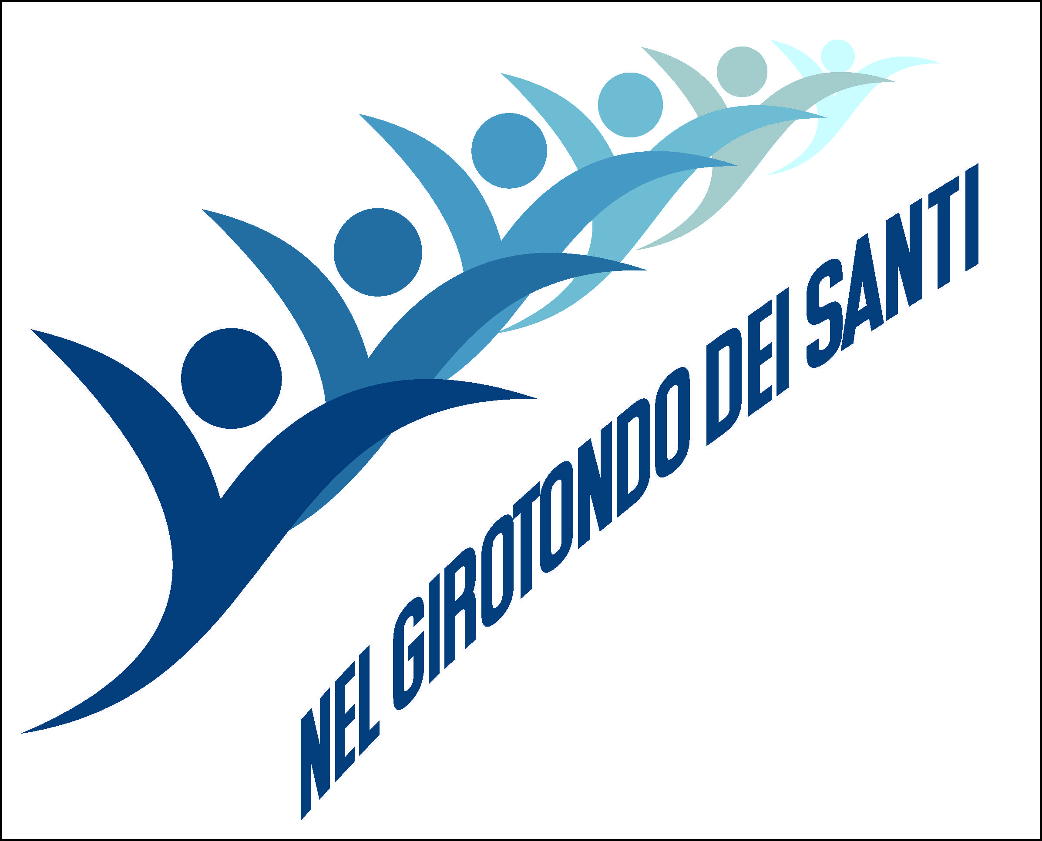
III Seminar for promotion
of the Causes of Beatification and Canonization
in the Salesian Family

Turin, 6 – 10 September 2023

Program

Wednesday 6 September

Arrival and accommodation

16.00 Eucharist – Votive of the Holy Spirit, presided over by the Rector Major, Fr Ángel Fernández Artime SDB (in S. Francesco di Sales)

17.00 Opening celebration of the Seminary

Greeting of the Rector Major

Presentation of the participants

Elements of Salesian holiness – Objectives of the Seminar
Intervention by Fr Pierluigi Cameroni SDB, General Postulator

18.30 Break

19.00 Vespers – Good night: Mother Chiara Cazzuola FMA (video message)

19.30 Dinner

Thursday 7 September
IN THE LIVES OF THE SAINTS
GIVE US AN EXAMPLE

07.00 Eucharist with lauds – For vocations, presided over by don Joan Lluís Playà SDB, Delegate for the Salesian Family (in S. Francesco di Sales)

08.00 Breakfast

9.00 Experiences of promoting Causes of beatification and canonization:

Venerable Francesco Convertini (Giancarlo Carbotti)
Teresa Valsè Pantellini (Sister Paola Cuccioli FMA)
Andrea Beltrami (Mrs. Barbara Cressoni)
Andrea Majcen (Fr. Alojzij Snoj SDB)

10.30 Break

11.00 Salesian Missal and Lectionary: editorial criteria and liturgical-pastoral use
Report by Prof. Elena Massimi FMA, Professor at the Salesian Pontifical University
Questions in the room

13.00 Lunch

15.00 Valdocco Land of Saints: celebration on Salesian places. By language groups

16.30 Pause

17.00 Fame of holiness and signs. What does it mean? What are the challenges for today?
Report by Sr. Francesca Caggiano FMA, Vice-Postulator

17.30 Group work: resonances to the report and sharing of experiences regarding the promotion of the Causes of Beatification and Canonization

18.30 Sharing in the assembly

19.10 Vespers

19.30 Dinner

20.30 Guided tour of the Casa Don Bosco museum.
By language groups

Friday, September 8
IN INTERCESSION
HELP AND SUPPORT

07.00 Eucharist with lauds, Nativity of the Blessed Virgin Mary, presided over by Father Sergio La Pegna DC (in St. Francis de Sales)

08.00 Breakfast

09.00 The miracle: ascertainment of scientific and theological elements – Diocesan Inquiry
Report of the Rev. Father Sergio La Pegna DC, Official of the Dicastery for the Causes of Saints
Questions in the room
10.30 Break

11.00 Presentation of some miracle cases –ROUND TABLE

Dr. Massimo Bonzanino: miracle for the canonization of Artemide Zatti
Dr. Maurizio Bruni: miracle for the beatification of Camille Costa de Beauregard and miracle for the beatification of Maddalena Morano
Sister Francesca Caggiano FMA: alleged miracle for the canonization of Maria Troncatti
Sister Antonietta Bosetti SSGC: miracle for the beatification of Maria Carola Cecchin

Questions in the room

13.00 Lunch

15.00 Group work: sharing experiences and initiatives on the themes of the day

16.00 Sharing in the assembly

16.30 Pause

17.00 It is the Spirit who shapes the Saints
Report by Dr. Lodovica Maria Zanet, collaborator of the Postulation
Questions in the room

19.00 Vespers – Good night

19.30 Dinner

20.30 Holy Rosary in the Basilica of Mary Help of Christians

Saturday, September 9
IN COMMUNION A BOND
OF FRATERNAL LOVE

07.00 Breakfast

08.00 Departure for Colle Don Bosco (Praise by bus)

9.00 Visit to Colle Don Bosco. By language groups

11.00 Break

11.30 Eucharist – Votive of St. John Bosco, presided over by Father Thathireddy Vijaya Bhaskar SDB, Director of Colle

12.30 Lunch

14.30 Presentation of lay holiness in the light of the Strenna 2023

Akash Bashir (Father Gabriel Cruz SDB)
Vera Grita (Maria Rita Scrimieri)
Simão Bororo (Father Joao Bosco SDB)
Alexandre Planas (don Joan Lluís Playà SDB)

16.00 Departure for Capriglio and visit to the places of Mamma Margherita. Testimony of Diego Occhiena

18.30 Return to Valdocco (Vespers by bus)

19.30 Dinner

21.00 Good night of the Rector Major

Sunday, September 10
COMFORTED BY THEIR TESTIMONY
WE FACE
THE BATTLE OF FAITH

7.30 Lauds (in S. Francesco di Sales)

08.00 Breakfast

09.30 Eucharist presided over by the Rector Major Fr. Ángel Fernández Artime (in the Basilica)

10.30 Break

11.00 The State of the Causes and the tools to promote them
Report by Fr. Pierluigi Cameroni SDB, General Postulator
Questions in the room

The documentation on the Servant of God Luigi Bolla in the Salesian Historical Center of Peru (Prof. Franco David)

Intervention of the Rector Major Don Ángel Fernández Artime

Conclusion

13.00 Lunch – Departure

